3.3 Complex Numbers
When you learned about square roots, you found out that you cannot take the square root of a negative number.

An imaginary number is defined as $i = \sqrt{-1 }$, $i^{2}=-1$.

Recall that
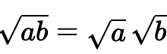

This allows us to simplify expressions involving the square root of a negative number.

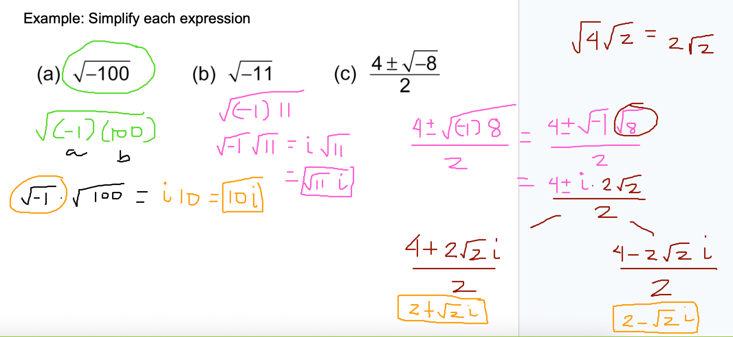

$\frac{8±\sqrt{-20}}{2}$

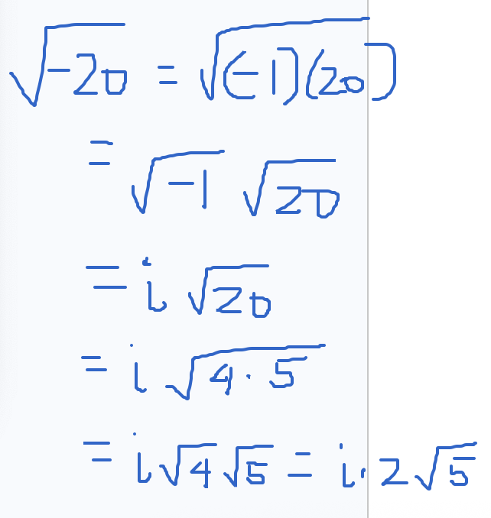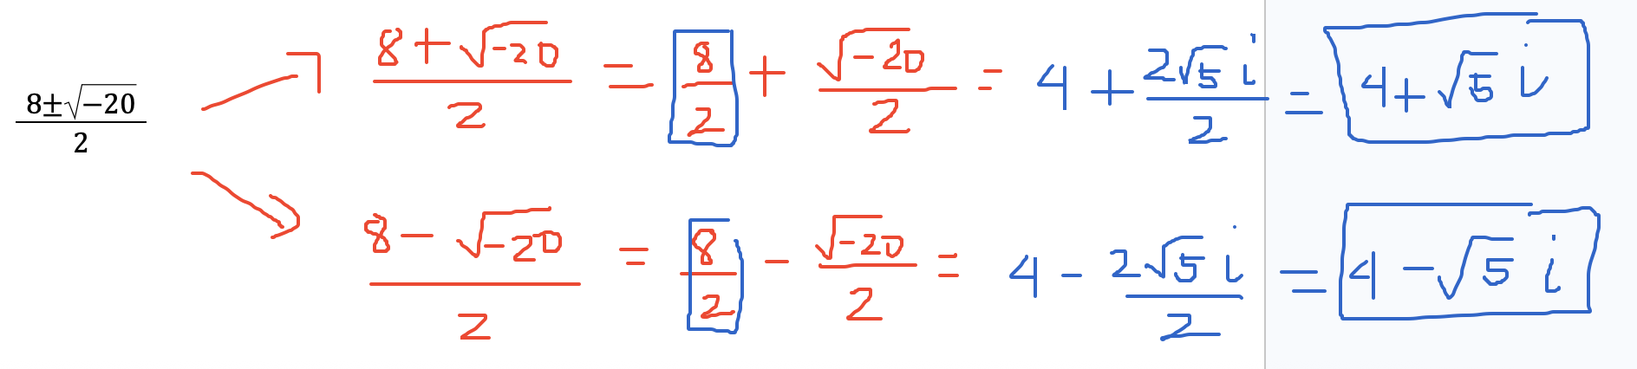

Example: Simplify each expression
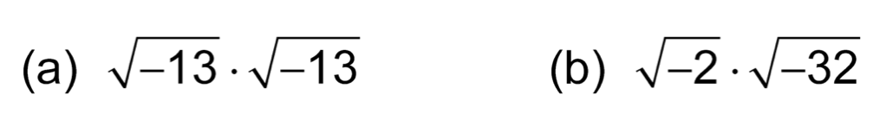

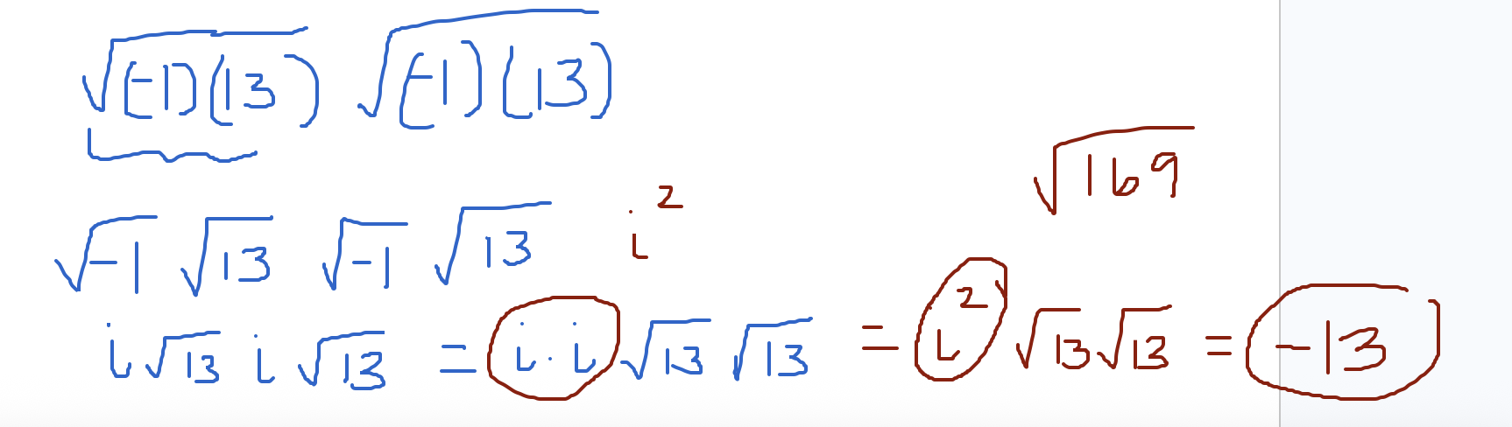

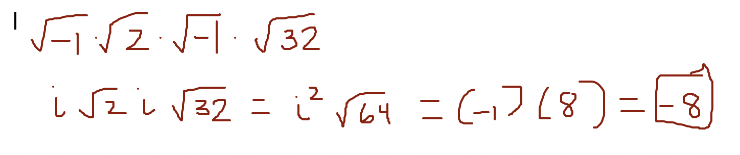
Simplify a) $\sqrt{-64}$ and b) $\sqrt{-10}\sqrt{-10}$

a) $\sqrt{-64}=\sqrt{(-1)(64)}=\sqrt{-1}\sqrt{64}=i(8) = 8i$
b) $\sqrt{-10}\sqrt{-10}=\sqrt{-1}\sqrt{10}\sqrt{-1}\sqrt{10}=i\sqrt{10}i\sqrt{10}=i^{2}\sqrt{10}\sqrt{10}=i^{2}\sqrt{100}=-10$

Complex number
A complex number is a + bi, where a and b are real numbers. Ex: 2 + 3i, -3 - 5i, $\frac{1}{2}+3i$

To simplify operations involving complex numbers, combine like terms. For addition, subtraction, and multiplication, combine the real parts of the complex numbers and combine the imaginary parts.

The conjugate of a complex number a + bi is a - bi. Ex: The conjugate of 3 + 2i is 3 - 2i. The conjugate of -3 - 5i is -3 + 5i. For division, multiply the numerator and denominator by the conjugate, and simplify.

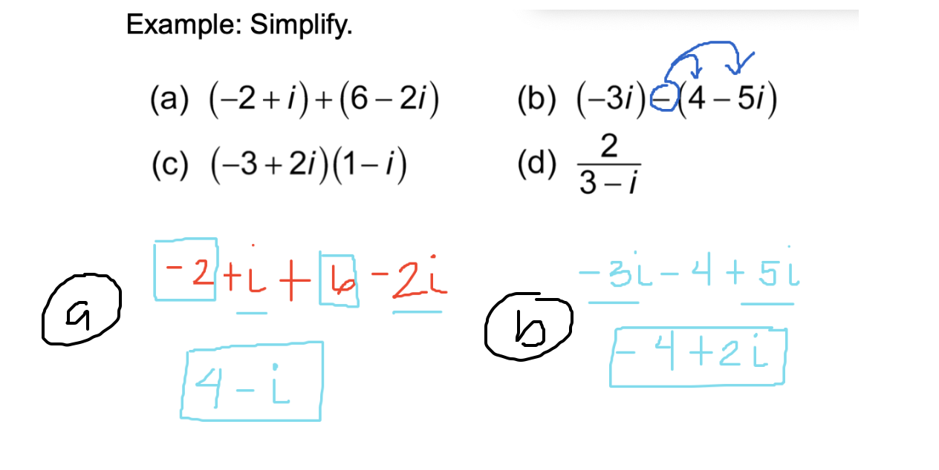

(c)

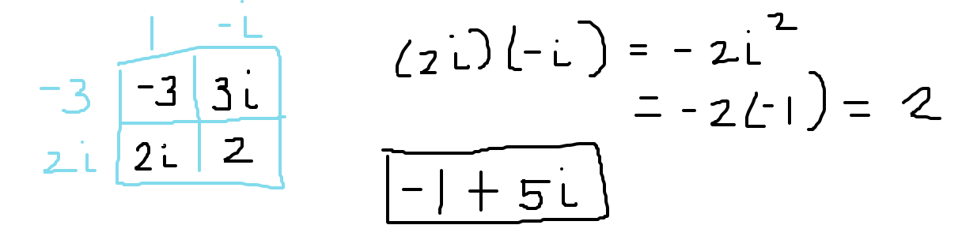

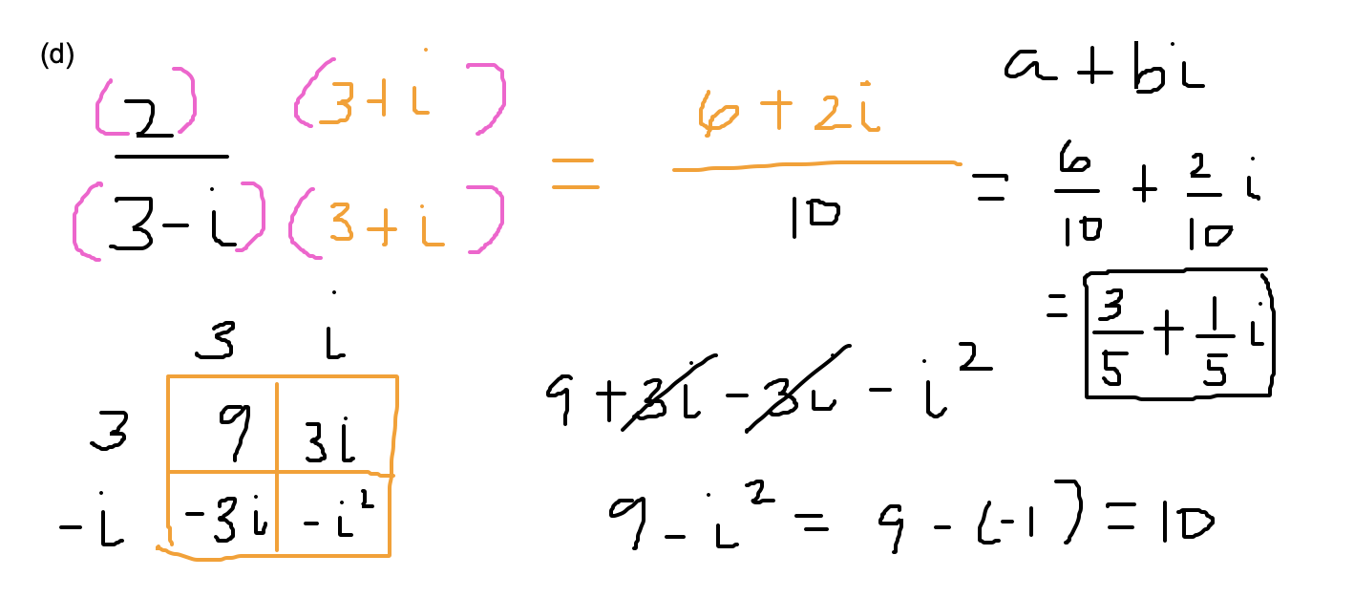

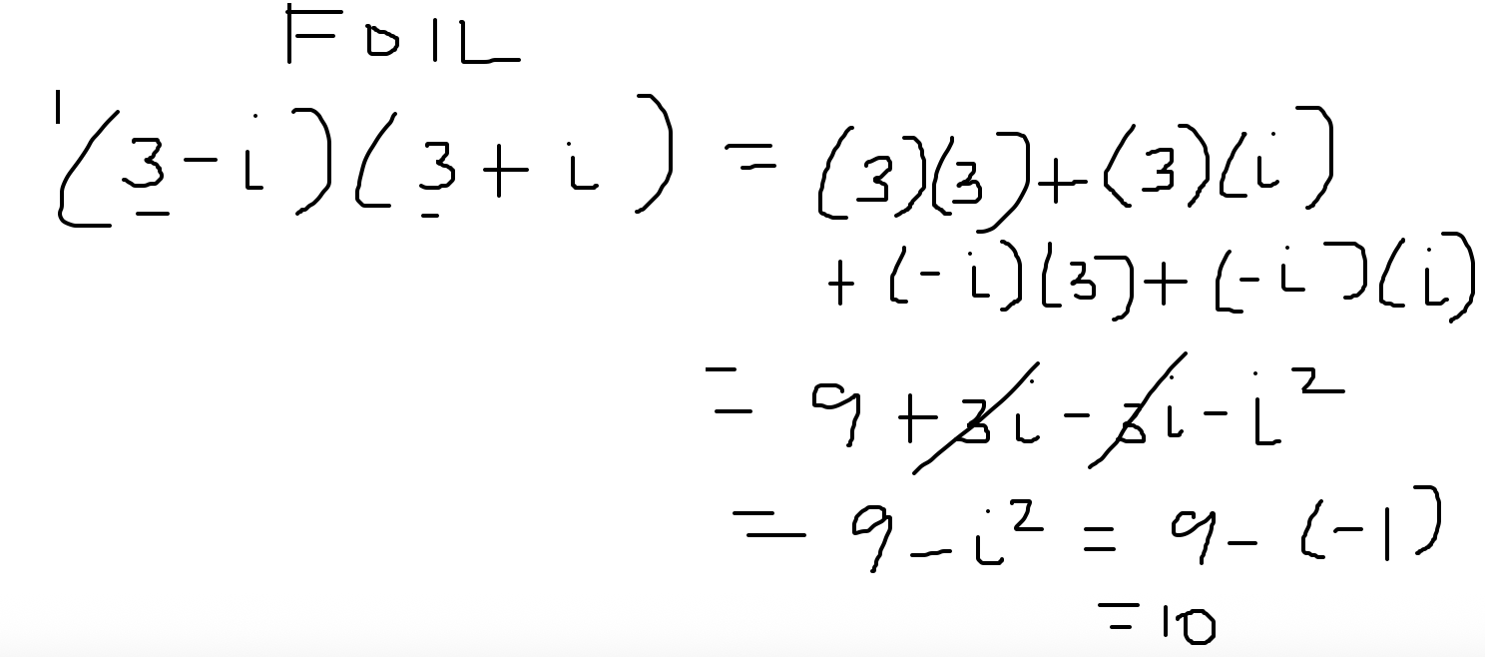

Simplifying powers of i
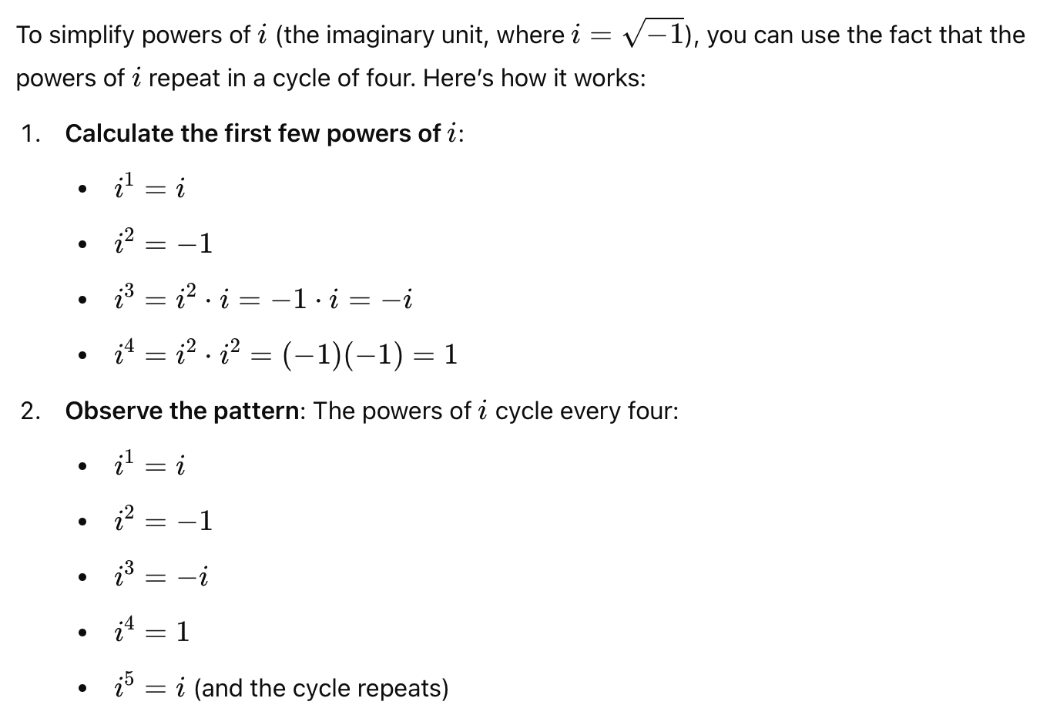

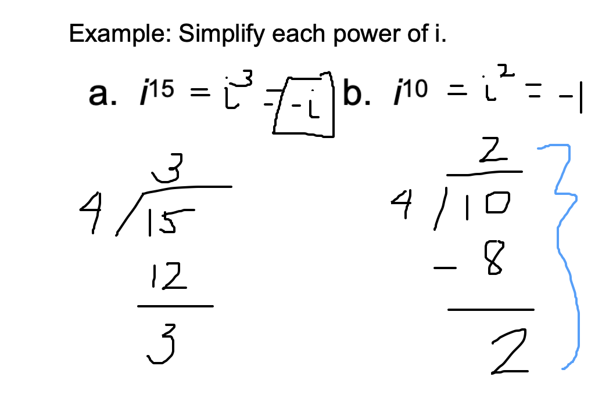

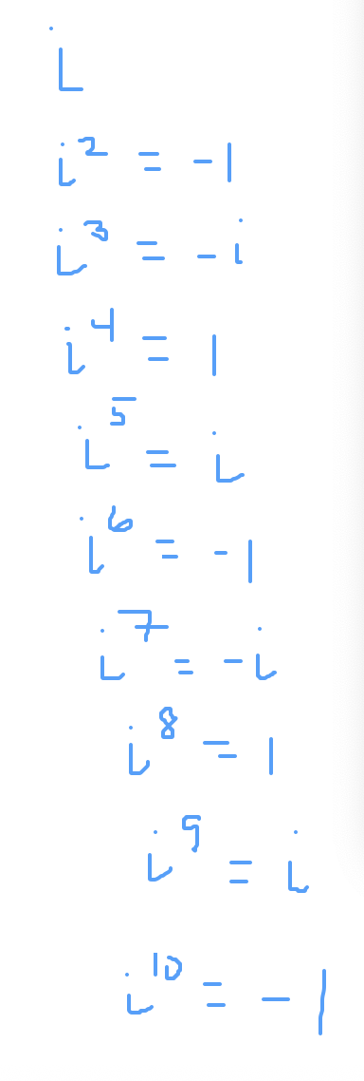

Example
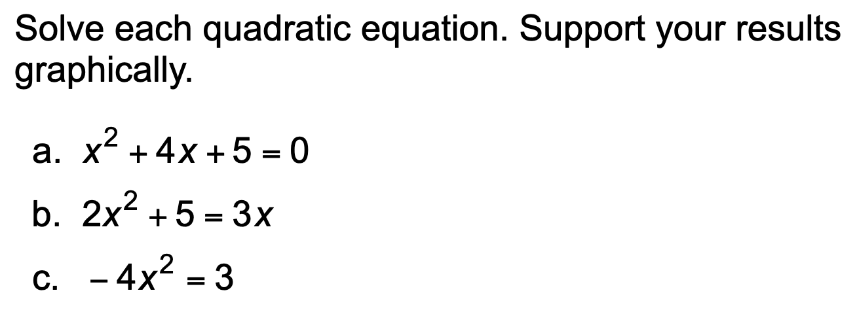

(a)

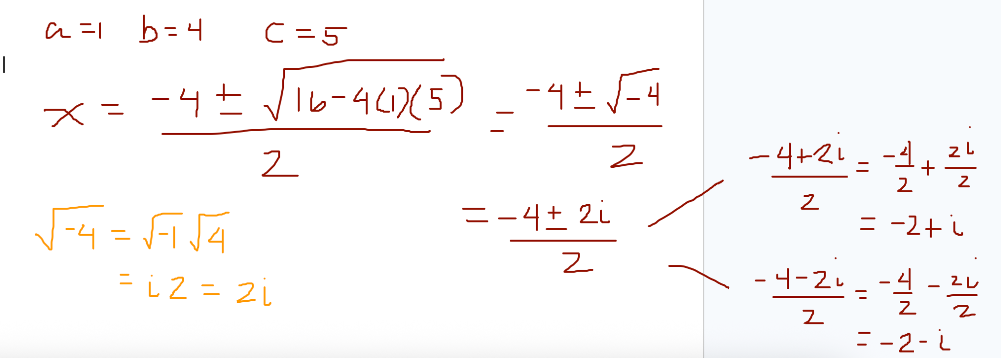

(c)

